ROUND 1

Numbers and letters. Well known things with both numbers and letters with only the numbers and first letters (except small words).

e.g.

3 F in a Y = 3 feet in a yard

3 B M = 3 blind mice

1. 101 D 101 dalmations

2. 24 H in a D 24 hours in a day

3. H 57 V Heinz 57 varieties

4. 27 C in the E U 27 countries in the European

5. 8 P in the S S 8 planets in the solar system

6. T 39 S The 39 Steps

7. 20,000 L U the S 20,000 Leagues under the Sea

8. 6 S on a H 6 sides on a hexagon

9. A 13 Apollo 13

10. 12 I in a F 12 inches in a foot

ROUND 2

Here are some common bird songs (groan!) all heard in the garden.

1. Tm Blackbird

2. Cp Woodpigeon

3. Sa Tawny owl

4. La Herring gull

5. Dm Great Spotted Woodpecker

6. Cc Cuckoo

7. Cc Hooded Crow

8. Pv Green Woodpecker

9. Er Robin

10. Ue Hoopoe

ROUND 3

Which movies/TV shows do these clips come from?

1. Carpet Star Wars IV

2. Class Finding Nemo

3. Ant The Avengers

4. Score Jaws

5. Mission The 5th Element

6. Boom The Italian Job

7. Finale The Hunger Games

8. Common Charlie and the Chocoloate F..

9. Strange Inception

10. Housekeeper Sherlock

ROUND 4

Which countries are these flags from?

1.  Canada

2.  Niger

3. 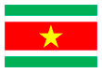 Suriname

4.  Japan

5.  Poland

6.  Turkey

7. Macintosh HD:Users:andrewcottam:Desktop:flag 7.png Sri Lanka

8. Macintosh HD:Users:andrewcottam:Desktop:flag 8.png Liberia

9.  Netherlands

10. Macintosh HD:Users:andrewcottam:Desktop:flag 10.png Australia

ROUND 5

Which countries are the famous landmarks in?

1. 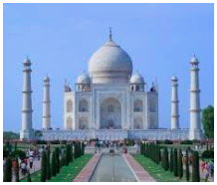 India

2. 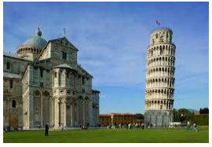 Italy

3. 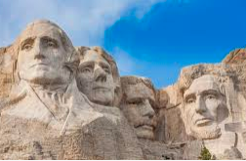 USA

4. 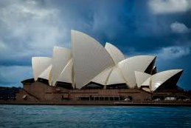 Australia

5. 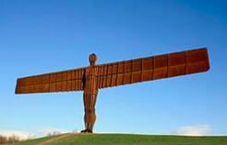 UK

6. 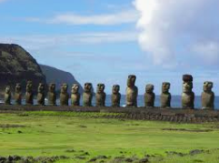 Chile

7. 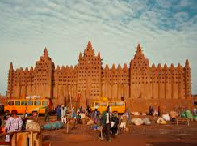 Mali

8. 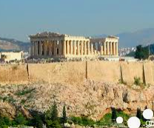 Greece

9. 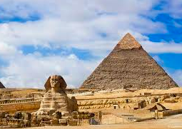 Egypt

10. 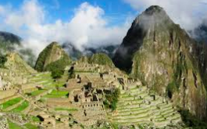 Peru

ROUND 6

Who said what? Match them up.

|  |  |
| --- | --- |
| Macintosh HD:Users:andrewcottam:Desktop:who 8.png | ‘Die, my dear?’ That’s the last thing I’ll do! |
| Macintosh HD:Users:andrewcottam:Desktop:who 1.png | Never give a sword to a man who can’t dance |
| Macintosh HD:Users:andrewcottam:Desktop:who 7.png | Never in the field of human conflict was so much owed by so many to so few |
| Macintosh HD:Users:andrewcottam:Desktop:who 2.png | Romeo, Romeo, wherefore art thou Romeo? |
| Macintosh HD:Users:andrewcottam:Desktop:who 10.png | I do not like that Sam I am |
| Macintosh HD:Users:andrewcottam:Desktop:who 3.png | In real life, I'm a really smiley person. I smile when I talk and I laugh. |
| Macintosh HD:Users:andrewcottam:Desktop:who 6.png | We're more popular than Jesus now; I don't know which will go first, rock 'n' roll or Christianity. |
| Macintosh HD:Users:andrewcottam:Desktop:who 5.png | Sausages are just funny. I don't know why. I can't explain it. |
| Macintosh HD:Users:andrewcottam:Desktop:who 4.png | I will build a great wall – and nobody builds walls better than me, believe me |
| Macintosh HD:Users:andrewcottam:Desktop:who 9.png | E = mc2 |

ROUND 7

Food and drink from chemical things.

1. BariumSodiumSodium Banana

2. RhondiumUraniumBariumUridium Rhubarb

3. BariumCobaltNickel Bacon

4. ScandiumOxygenTechnetiumHydrogen Scotch

5. SulphurPhosphorusAmericium Spam

6. SulphurGoldSulphurSilverElectron Sausage

7. ProtactiniumNitrogenCalciumPotassiumElectron

Pancake

8. QuarkUraniumIodineCarbonHelium Quiche

9. ArgonTitaniumCarbonHolmiumPotassiumElectron

Artichoke

10. TungstenHydrogenIodineSulfurPotassiumElectronYttrium

Whiskey

ROUND 8

Identify the smells

1. Cumin

2. Cloves

3. Lemon zest

4. Chocolate

5. Paprika

6. Dishwasher powder

7. Coffee

8. Strawberry

9. Cinnamon

10. Banana

ROUND 9

Collect leaves from the following trees

1. Common oak

2. Sweet Chestnut

3. Hornbeam

4. Corsican pine

5. Magnolia

ROUND 10

Name the artist

1. 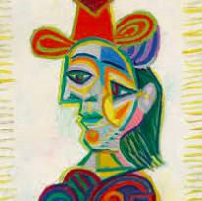 Picasso

2. 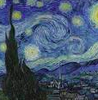 Van Gogh

3. 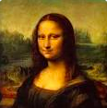 Leonardo Da Vinci

4. 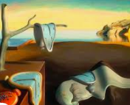 Salvador Dali

5. 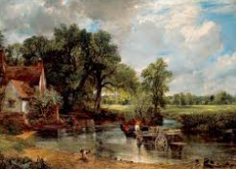 John Constable

6. 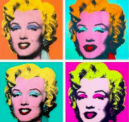 Andy Warhol

7. 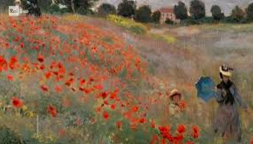 Claude Monet

8. 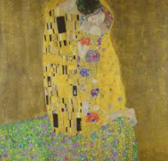 Gustav Kilmt

9. 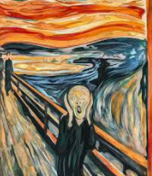 Edvard Munch

10.  Pieter Mondrian